|  |  |
| --- | --- |
|  | **School of Engineering**  **COURSEWORK SUBMISSION SHEET** |
|  |
| All sections must be completed and the declaration signed, for the submission to be accepted. All coursework should be submitted to turnitin through Campus Moodle.  **EXTENSIONS** –all requests for extensions must be submitted on the [Coursework Extension form](http://www.rgu.ac.uk/about/academic-affairs/quality-assurance-and-regulations/academic-regulations-student-forms), prior to the due date.  **LATE COURSEWORK** – coursework received late and without valid reason will be recorded as a Non-Submission (NS) and will be considered as one assessment opportunity. If applicable, a late submission should be submitted with a [Deferral Request Claim Form](http://www.rgu.ac.uk/about/schools-and-departments/administration-and-support/governance-and-academic-quality/quality-assurance-and-regulations/academic-regulations-student-forms) and the related supporting evidence.  **FIT TO SIT POLICY –** the University operates a Fit to Sit Policy which means that if you undertake an assessment then you are declaring yourself well enough to do so. Further details are available at: [www.rgu.ac.uk/academicregulationsstudentforms](http://www.rgu.ac.uk/academicregulationsstudentforms). | |

|  |  |
| --- | --- |
| **Coursework Due Date** | **12/12/2018** |

|  |  |
| --- | --- |
| **MATRIC No** | **1800903** |
| **SURNAME** | **BOK** |
| **FIRST NAME(S)** | **JOAN ABUS** |
| **COURSE TITLE** | **MSc IT for the Oil & Gas Industry** Choose an item. |
| **MODULE NUMBER & TITLE** | **ENM500 Petroleum Geoscience** |
| **ASSIGNMENT TITLE** | **PART B – Well Log Interpretation Exercise** |
| **LECTURER ISSUING COURSEWORK** | **Gbenga Oluyemi** |

|  |
| --- |
| I confirm: (a) the inclusion of my signature below (electronic or otherwise) certifies that the work undertaken for this assignment is entirely my own and that I have not made use of any unauthorised assistance.*  (b) that the sources of all reference material have been properly acknowledged.*  (c) that I accept that the School will dispose of uncollected coursework at the end of term via the paper recycling service.  (d) that I will retain a copy of all coursework until the end of my studies.  **\* For information on Academic Misconduct, refer to** [**http://www.rgu.ac.uk/about/academic-affairs/quality-assurance-and-regulations/academic-regulations-student-forms**](http://www.rgu.ac.uk/about/academic-affairs/quality-assurance-and-regulations/academic-regulations-student-forms)**]** |

|  |  |  |  |
| --- | --- | --- | --- |
| **Signed** | JOAN ABUS BOK | **Date** | **30/11/2018** |

|  |  |
| --- | --- |
| Marker’s Comments | |
| Marker | Grade |

**WELL LOG**

**INTERPRETATION EXCERCISE**

**WORKSHEET**

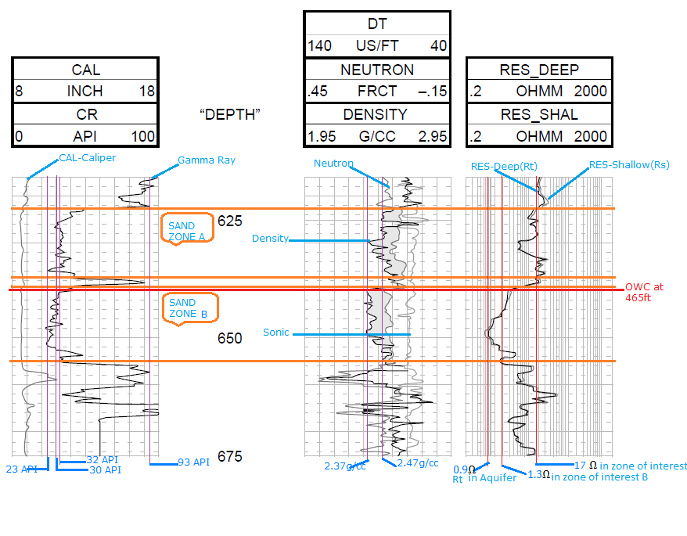

1. To calculate the volume of shale (Vsh), we first need to calculate the gamma ray index (IGR) from the gamma ray log.

IGR= (GRlog-GRmin) / (GRmax-GRmin)

Where, GRmax = maximum GR reading in shale

GRmin = minimum GR reading in sand

GRlog = GR reading of formation from log

**FOR ZONE A:**

GRlog = 32 API, GRmin = 23 API, GRmax = 93 AP1

IGR = (32 – 23) / (93 – 23)

**IGR = 0.128**

Using the Neutron log in this zone to determine the rock porosity to know if it is an old or young rock, it can be estimated at 0.07 which is low. With low porosity below 10%, it can be said that it is an old or tertiary rock. Hence using

Vsh = 0.33 * (22*IGR – 1.0) to find the Volume of shale,

Vsh =0.33 * (22*0.128 – 1.0)

**Volume of shale (Vsh) = 0.06 or 6%**

**FOR ZONE B:**

IGR = (30 – 23) / (93 – 23)

**IGR = 0.10**

Using the Neutron log in this zone to determine the rock porosity to know if it is an old or young rock, it can be estimated at 0.08 which is low. With porosity below 10%, it can be said that it is an old or tertiary rock. Hence using

Vsh = 0.33 * (22*IGR – 1.0) to find the Volume of shale,

Vsh = 0.33 * (22*0.10 – 1.0)

**Volume of shale (Vsh) = 0.049 or 4.9%**

Note that on the log sheet the Gamma Ray reading is high in shale (GRmax), this is because of the presence of radioactive minerals, and low in sand (GRmin) because of the absence of radioactive minerals (Darling, 2005).

1. The **likely OWC** position occurs at **645ft.** This can be seen as there is a crossover between the neutron and density logs from the beginning of the graph, and at 645ft neutron log touches the density log again, and at the same point there’s a **sharp drop** in the deepest resistivity log reading (Rt). Both occurrences indicate a change in zone from oil to water.
2. **Porosity is calculated from the Density log using**:



Where:

ρma = Matrix density

ρb = Bulk density

ρf = Fluid density

Given grain density, ρma = 2.66g/cc

Well drilled fresh water WBM, ρf =1.0g/cc

**FOR ZONE A:**

From Density log, ρb = 2.47g/cc

Substituting values into the porosity equation

Ø = (2.66 – 2.47) / (2.66 – 1.0)

Ø **= 0.114 or 11.4%.** This can be described as a slightly porous reservoir.

**FOR ZONE B:**

From Density log, ρb = 2.37g/cc

Substituting values into the porosity equation

Ø = (2.66 – 2.37) / (2.66 – 1.0)

**Ø = 0.174 or 17.4%.** This can be described as a very porous reservoir.

The Density calculated using the density log tool is referred to as **total porosity value.** This is because the density log tool only measures in the invaded zone which contains mud filtrate i.e. water mixed with clay. This results in errors and very high porosity values. Several factors that affect the porosity measured from the density log are:

* The effect of wash out in the zone.
* The effect of gas which reduces fluid density in the zone.
* The presence of shale, as it has varying densities. (Oluyemi, 2018)

1. **TO CALCULATE WATER SATURATION Sw:**

Using Archie’s equation:



Where,

Sw = water saturation,

Ø = porosity,

a = tortuosity factor = 1,

m = cementation factor = 2

Rw = formation of water resistivity (shallow),

Rt = true resistivity (deep)

**FOR ZONE A:**

Ø = 0.114

To find **Rw in the 100% water zone (aquifer),**

Substituting Rt = 0.9Ω, Sw = 1 into the Archie’s equation above to find Rw;

Rw = SW2 * Ø2Rt

= 12 *(0.114)2 *0.9

**Rw = 0.012**Ω.The low resistivity indicates that the formation is porous hence there is high electric conduction. (The value of Rw is said to be low if it ranges between 0.5 to 0.05 ohm).

In the zone of interest,

Rt = 17Ω and Using Archie’s equation to find Water saturation (Sw);

Sw = √ (1*0.012) / (0.114)2 * 17

**Sw = 0.23 or 23%.** This implies a **water saturation of** about **23%** and a **hydrocarbon saturation of 77%**.

**FOR ZONE B:**

Ø = 0.174

To find **Rw in the 100% water zone (aquifer),**

Substituting Rt = 0.9Ω, Sw = 1 into the Archie’s equation above to find Rw;

Rw = SW2 * Ø2Rt

= 12 *(0.174)2 *0.9

**Rw = 0.027**Ω**.** The low resistivity value in the aquifer indicates that there is high volume of water and high porosity. This is because water is a very good conductor of electricity and the water in the pores of the formation make this conduction possible (Darling, 2005).

In the zone of interest,

Rt = 1.3Ω and Using Archie’s equation to find Sw;

Sw = √ (1*0.027) / (0.174)2 * 1.3

**Sw = 0.82 or 82%.** This implies a **water saturation of** about **82%** and a **hydrocarbon saturation of about 18%.** The high volume of water in the zone signifies the prevalence of water in this zone.

REFERENCES:

DARLING, T., 2005. *Well Logging and Formation Evaluation.* USA: Gulf Professional Publishing.

OLUYEMI, G. *EMN-500* *Formation Evaluation*, November 15 2018 [PowerPoint Presentation].